**Lab Exercise 10– Creating an AWS RDS Instance in Terraform**

Objective: Learn how to use Terraform to create an AWS RDS instance.

**Steps:**

1. **Create a Terraform Directory:**



2**. Create Terraform Configuration Files:**

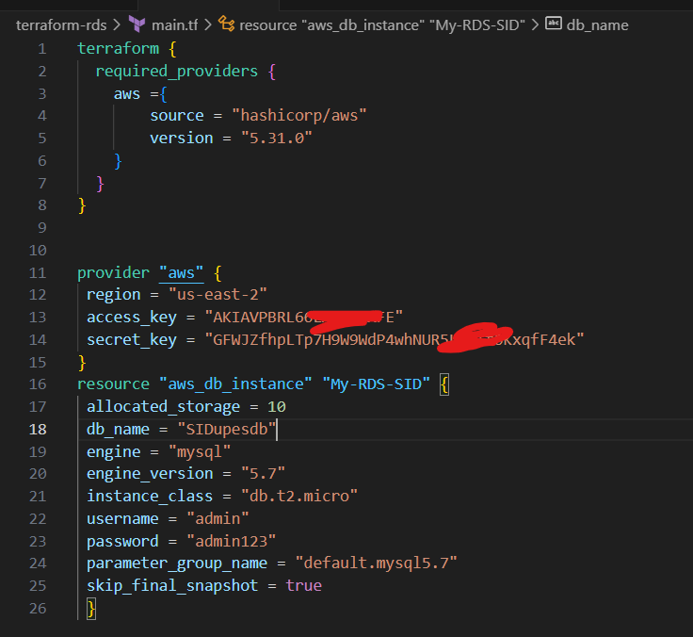

3. **Initialize and Apply:**

**terraform init**

**terraform apply**

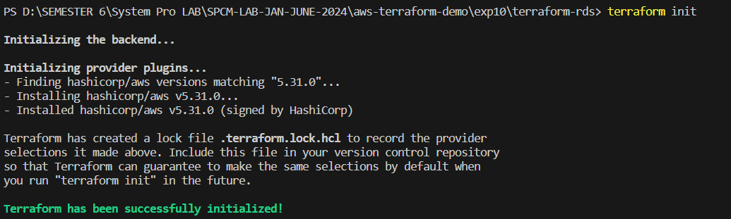

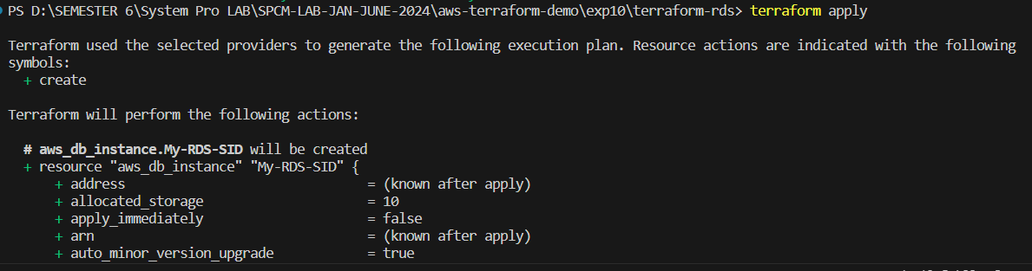

**4. Verify RDS Instance in AWS Console:**

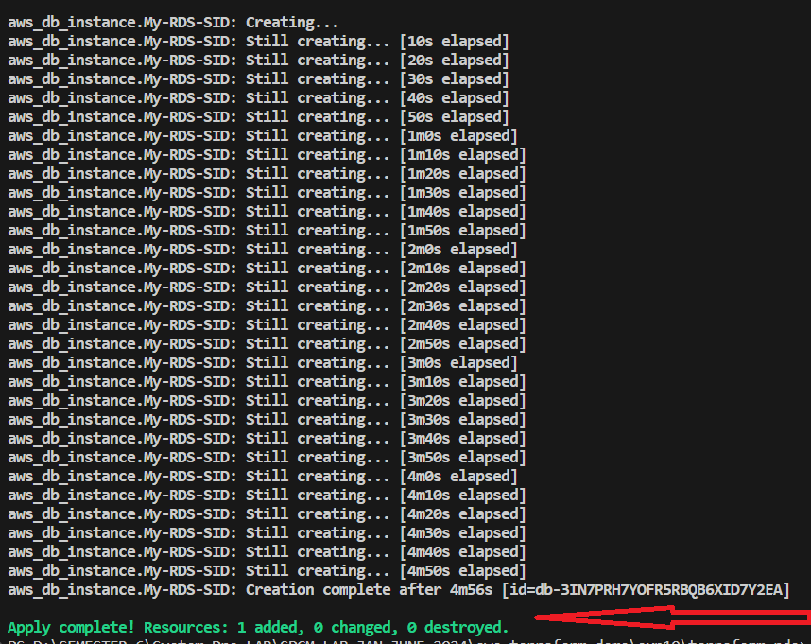

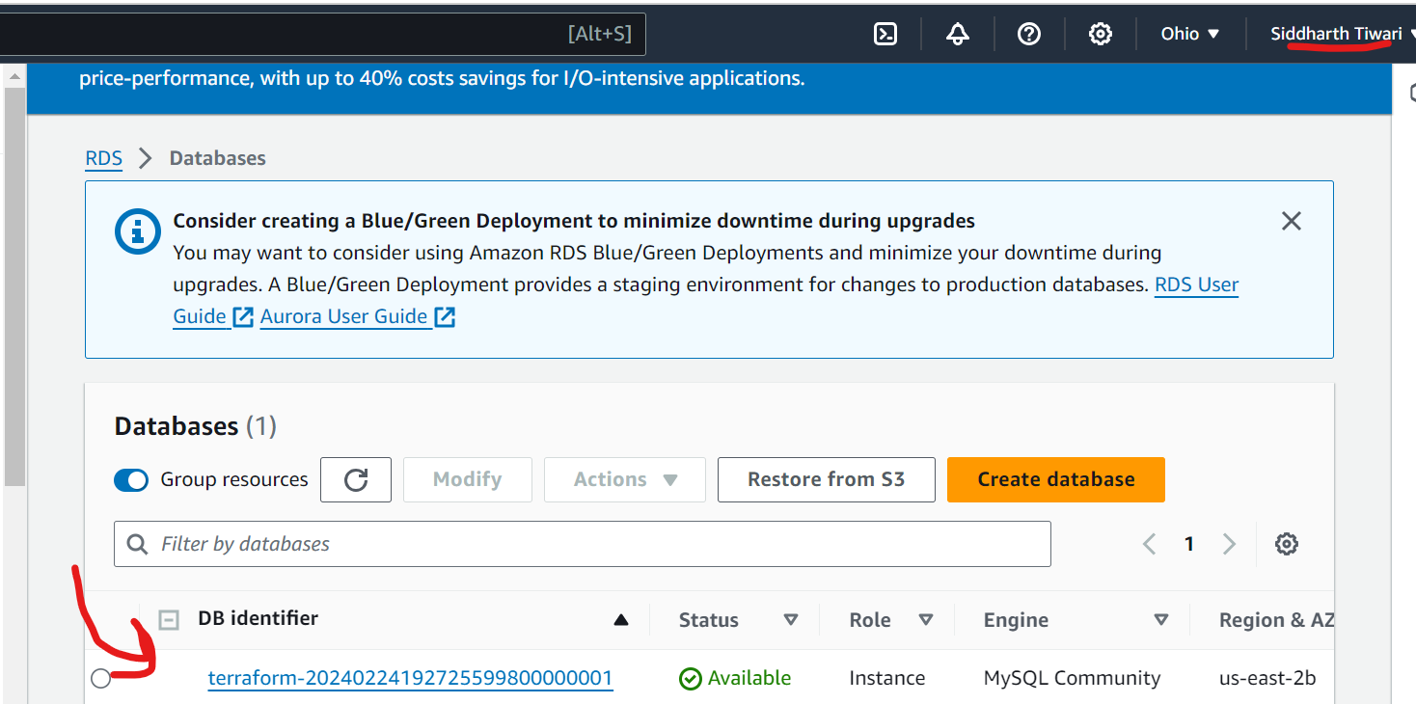

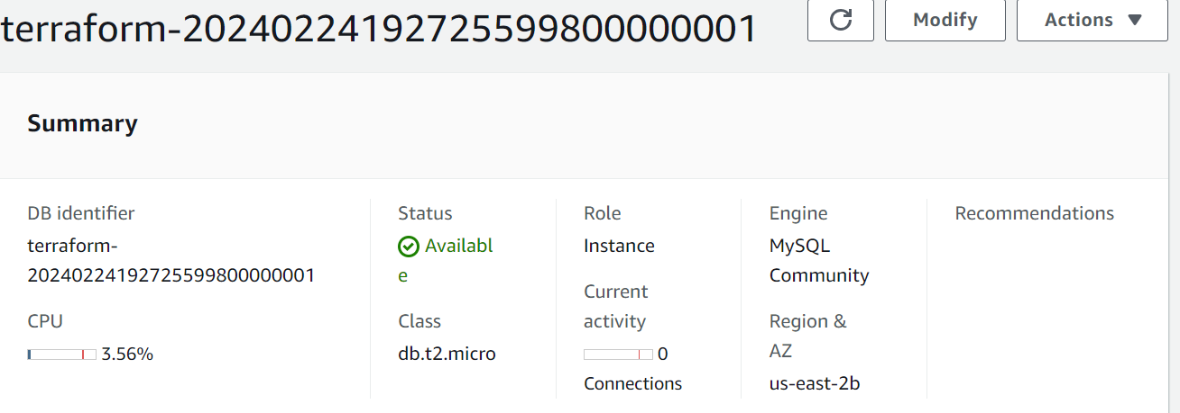

6. **Clean Up:**

**terraform destroy**



